Backend Development using Node.js and Express
TEAM DETAILS
Team leader | S.Vijayabharathi

TEAM MEMBERS
MEMBERS | NAME
Member 1 | S.Vijayabharathi
Member 2 | V.Yuvathy
Member 3 | A.Anandha jothi
Member 4 | A.Abinaya

PROJECT TITLE
Contact Manager
INTRODUCTION
A Contact Manager is a software application used to store, organize, and manage contact information of people. It helps users keep details such as names, phone numbers, email addresses, and addresses in one place.
A contact manager allows users to easily add, edit, delete, and search contacts whenever needed. It is commonly used in mobile phones, computers, and business systems to maintain personal and professional contact lists.
The main purpose of a contact manager is to make communication easier and more organized. Instead of remembering many phone numbers or writing them in notebooks, users can quickly access the required contact information through the system.
Contact managers are also useful for saving time, avoiding data loss, and managing large numbers of contacts efficiently

PROJECT OVERVIEW
The ConnectHub is a backend web application designed to solve the common problem of scattered contact information across multiple platforms. It provides users with a centralized, organized system to store, search, and categorize their professional and personal contacts.

Key Objective
- Store Contact Information – To keep details like name, phone number, email, and address in one place.
- Easy Access – To quickly find and use contact details whenever needed.
- Organize Contacts – To arrange contacts in a structured and systematic way.
- Save Time – To reduce time spent searching for phone numbers or addresses.
- Improve Communication – To help users connect with people easily.
- Data Safety – To securely store contact information and avoid data loss.

Features

- Add Contact – Users can add new contact details.
- Edit Contact – Users can update or change existing contact information.
- Delete Contact – Users can remove contacts that are no longer needed.
- Search Contact – Quickly find a contact using name or number.
- Contact List View – Displays all saved contacts in an organized list.
- Import/Export Contacts – Allows contacts to be transferred between devices.
- Backup and Restore – Helps protect contact data and recover it if lost.

Scope of the Project
The scope of the Contact Manager system is to provide a simple and efficient platform for storing and managing contacts. The system can be used by individuals, small businesses, and organizations to maintain their contact lists.
This project focuses on:
- Managing personal and professional contacts
- Storing important contact information
- Providing search functionality for quick access
- Allowing easy editing and deletion of contacts
The system can be implemented on computers or mobile devices, making it accessible for everyday use.

System Requirements

Hardware Requirements

- Computer or Laptop
- Minimum 2GB RAM
- Hard disk with sufficient storage
- Keyboard and mouse
Software Requirements
- Operating System (Windows / Linux / Android)
- Programming Language (Java / Python / C++)
- Database (MySQL / SQLite)
- Development Environment (Eclipse / VS Code / NetBeans)

MODULES
- Add Contact Module – Allows users to enter new contact details.
- View Contact Module – Displays all saved contacts.
- Search Contact Module – Helps users find contacts quickly.
- Update Contact Module – Allows modification of existing contacts.
- Delete Contact Module – Removes contacts that are no longer required.

PROJECT SETUP ABD CONFIGURATION
Folder Structure

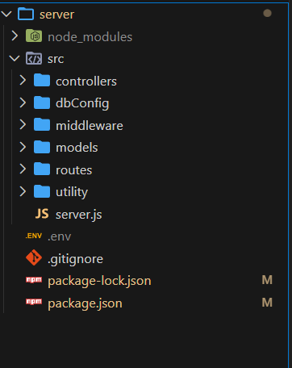

Project Setup
1. Install required tools and software:
• Node.js.
• MongoDB.
2. Create project folders and files:
• Server folders.
3. Install Packages:
Backend npm Packages
• Express.
• Mongoose.
• Cors.

IMPLEMENTATION
The implementation phase involves developing the actual program based on the design. The program is written using a programming language and includes functions for managing contacts.
During implementation, the developer ensures that the system works correctly and performs all required operations efficiently.

PROJECT INSTRUCTION
1️⃣ Install Node.js (If Not Installed)
Download and install Node.js from: https://nodejs.org/
After installation, verify:
node -v
npm -v
2️⃣ Create a Backend Project Folder
• Choose or create a directory where you want your backend.
• Open your terminal or command prompt.
• Navigate to the selected directory:
cd your-project-folder
• Create a new backend folder:
mkdir server
cd server
3️⃣ Initialize Node Project
Run: npm init -y
This will create a package.json file.
4️⃣ Install Required Dependencies
Install Express:
npm install express
npm install mongoose
For development (auto-restart server):
npm install nodemon --save-dev
5️⃣ Create Basic Server File
Inside the server folder:
• Create a file called: server.js
Add this code :
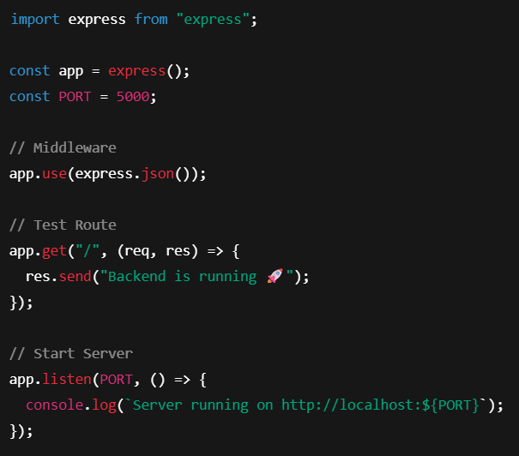

6️⃣ Enable ES Modules (Important)
Open package.json and add: "type": "module"
Example:
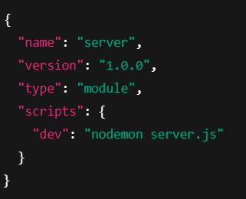
7️⃣ Start the Backend Server
Run: npm run dev
OR if not using nodemon: node server.js

8️⃣ Open in Browser
Open: http://localhost:5000
You should see: Backend is running

PROJECT EXECUTION
Execution Steps
- Open the project folder in the terminal
- Make sure you have a start script in the package.js file
- Use the command npm start to start the server
- You will the Running on PORT message on the successfully starting the server
- You will also see the database connected message if the database is connected successfully
- Use the Thunder client or Postman for using the created api’s

TESTING
Testing is an important phase of software development. It ensures that the system works correctly and meets the requirements.
Functional Testing – Ensures each feature works correctly.
Input Testing – Checks if the system handles different inputs properly.
Output Testing – Verifies that the correct results are produced.

ROLES AND RESPONSIBILITY

- User -
- Registration - Register on the application using the name, email , password
- Login - Login on the application using the email and registered password
- Search - Search for a contact using name , email or tags
- Add Contact - Add new contact - name , email , phone , notes , tags
- Edit Contact - Edit the existing contact
- Delete Contact - Delete any contact

ADVANTAGES AND LIMITATIONS
Advantages:
  - Easy to use
  - Saves time
  - Organized contact storage
Limitations:
  - Basic version may not support large databases
  - Requires a device to access

FUTURE ENHANCEMENT
- Integration with mobile devices
- Cloud storage support
- Contact photo storage
- Backup and restore features

Output Screenshots
- Register Api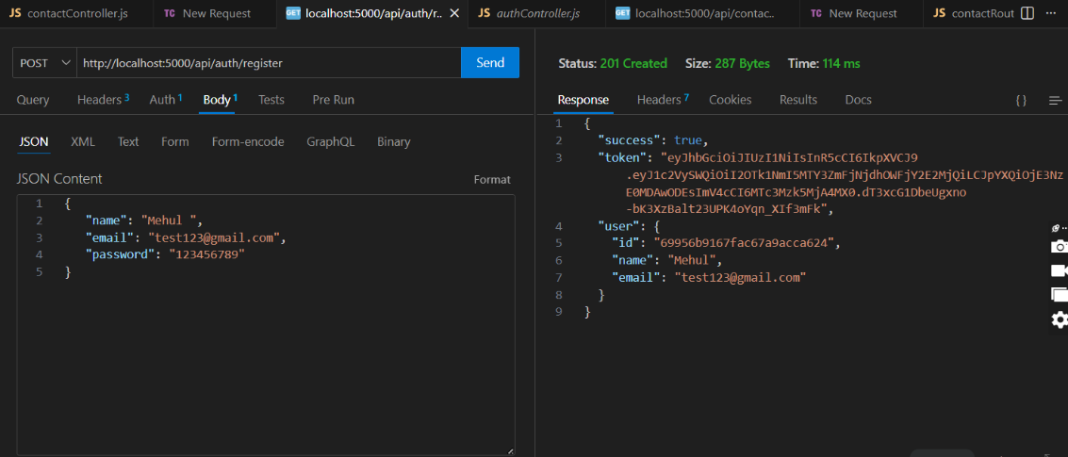

- Login Api
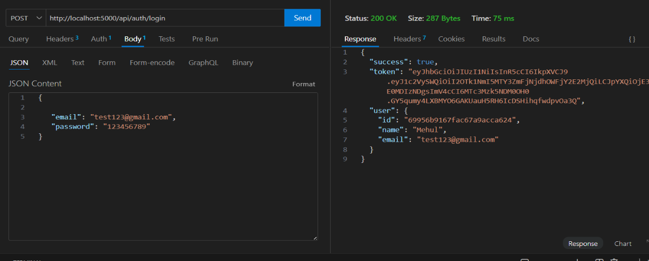
- Create New Contact
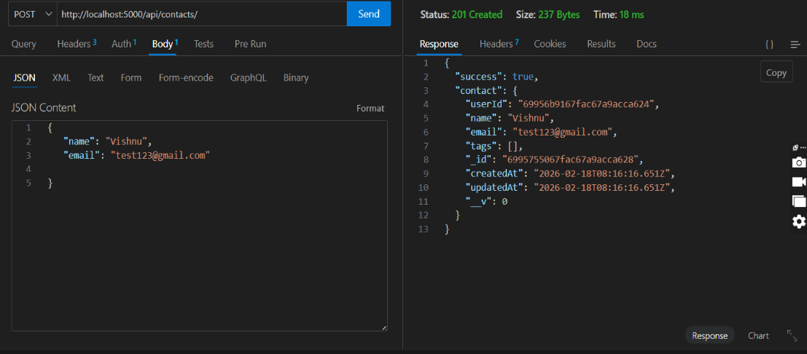

- Update Contact
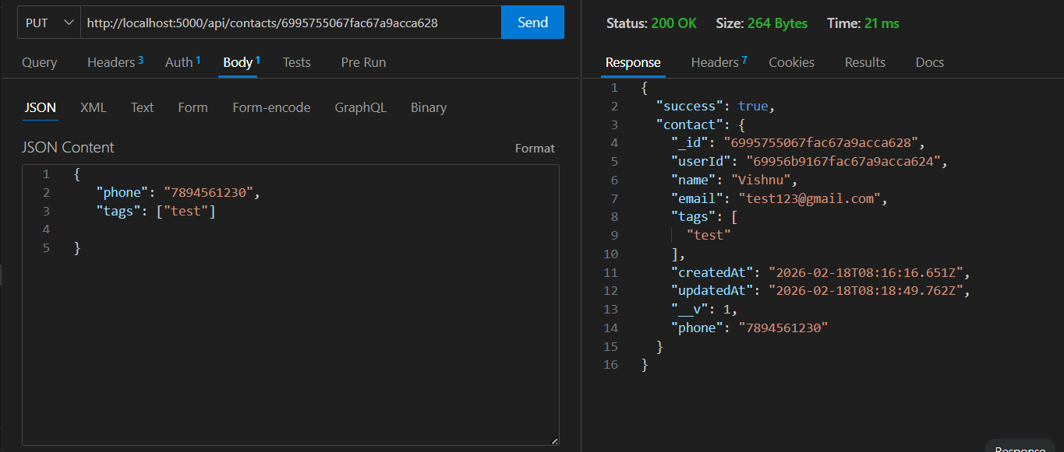

- Delete Contact
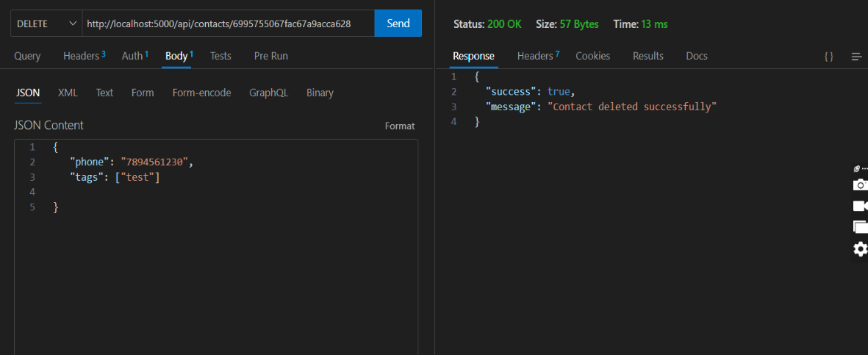

6.Search Contact
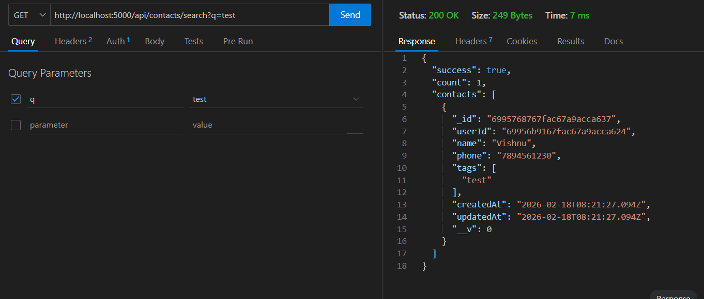

- Get The Current User
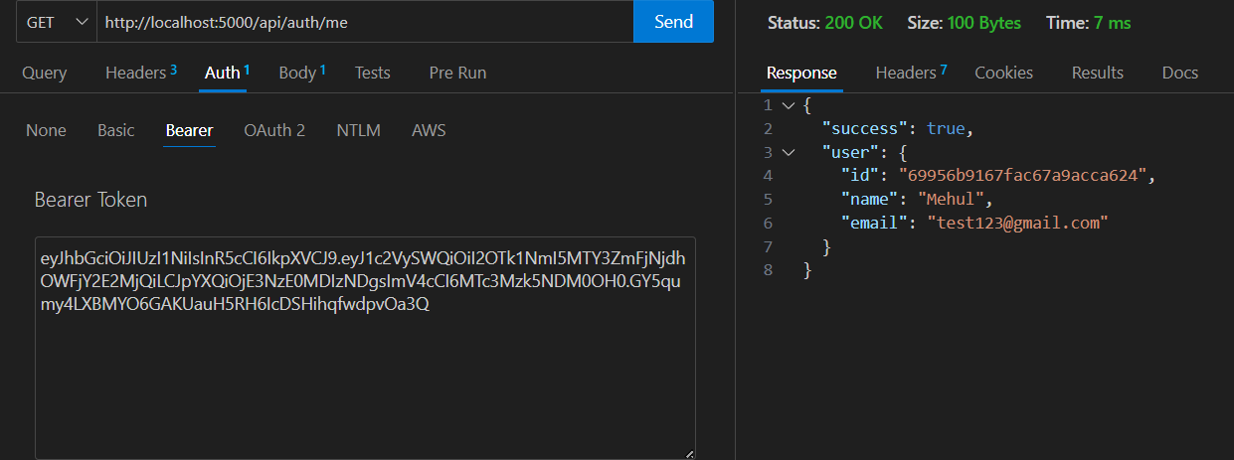

CONCLUSION
The Contact Manager System is a useful application for managing contact information. It provides simple and effective features for storing and retrieving contact details. The system improves organization and saves time compared to manual methods.

